Os skill2
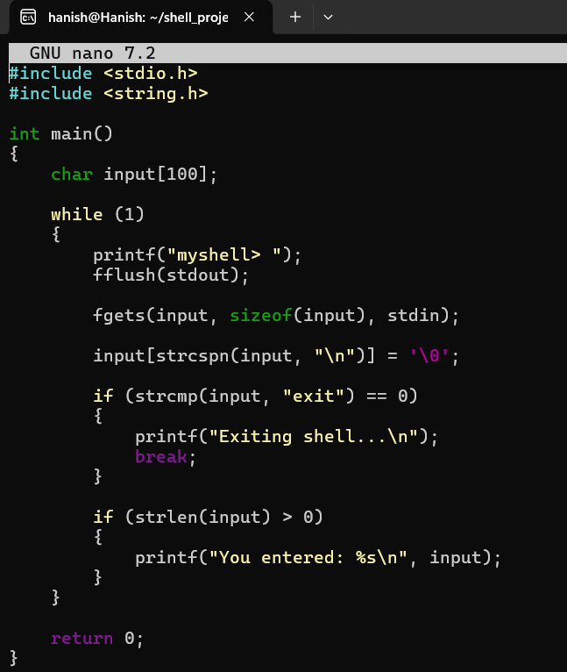

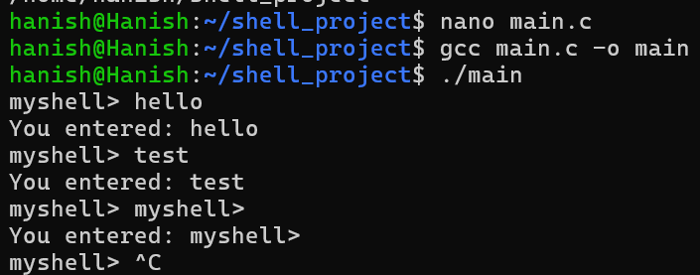

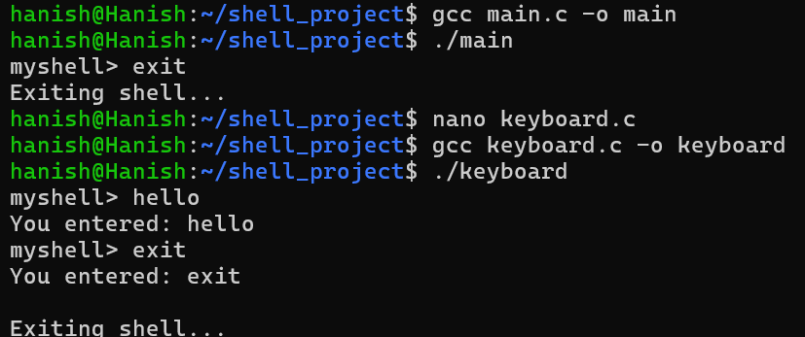

#include <stdio.h>
#include <unistd.h>
#include <termios.h>
#include <string.h>

void enable_raw_mode()
{
struct termios raw;

tcgetattr(STDIN_FILENO, &raw);

raw.c_lflag &= ~(ICANON | ECHO);

tcsetattr(STDIN_FILENO, TCSAFLUSH, &raw);
}

void disable_raw_mode()
{
struct termios normal;

tcgetattr(STDIN_FILENO, &normal);

normal.c_lflag |= (ICANON | ECHO);

tcsetattr(STDIN_FILENO, TCSAFLUSH, &normal);
}

int main()
{
char buffer[100];
int position = 0;
char ch;

enable_raw_mode();

printf("myshell> ");
fflush(stdout);

while (1)
{
read(STDIN_FILENO, &ch, 1);

if (ch == '\n' || ch == '\r')
{
buffer[position] = '\0';

printf("\nYou entered: %s\n", buffer);

if (strcmp(buffer, "exit") == 0)
{
break;
}

position = 0;

printf("myshell> ");
fflush(stdout);
}

else if (ch == 127)
{
if (position > 0)
{
position--;

printf("\b \b");
fflush(stdout);
}
}

else
{
if (position < 99)
{
buffer[position] = ch;
position++;

printf("%c", ch);
fflush(stdout);
}
}
}

disable_raw_mode();

printf("\nExiting shell...\n");

return 0;
}

